**Hostel Leave Management System**

**Aim of the Project:**

1. To give students different types of leaves inside campus after the Hostel closing time efficiently without manual intervention of warden and proctor each time.

2. To provide students a platform to ask for hostel leave permissions online.

3. To manage and store the student’s hostel and outing details.

**Software Requirements:**

HTML, CSS, Javascript, React-JS, Node-JS, JQuery, MongoDB/MariaDB, Google Cloud Compute Engine(Hosting).

**Abstract:**

· The website will have a single introductory web page consisting of multiple modules such as ‘Home’, ‘Outing’, ‘Night Garage Access’, ‘Library Leave’ etc.

· There will be a ‘Learn More’ module in the webpage which will be explaining more about the site.

· A section will be available in the webpage listing all the different types of leaves and outings that can be applied online by students

· A section of the website will be displaying demos about how to fill the form and required documentations before applications.

· Another login page for administrative authorities which will provide them the access to view all the data regarding leaves

· The authorities will be able to approve or reject the leave applications

. The leave applications are organized on the basis of priority depending on leave type and shown to the authorities on their login page.

· The leave applications will be verified on the gate by security guards by scanning the QR code generated on the website after the approval of application.

. Also an additional service of other Hostel’s Gym usage by generating a pass for 15 days and no need to sign on the gate. Just show the QR code pass on the gate.

· CSS styling and Animations will be added to different modules of the webpage, in order to make the website look more attractive and user friendly.

· A status module will be available after the administrator login, where the admin will be able to view the status of various outings and leaves. For example, the admin will be able to view all the outing requests, and upon confirmation of all the personal details and documentations of the students, the admin will be able to confirm the outing. If the outing has been approved, the admin will be able to view the approved outing in a separate tab, along with all the details of the respective students.

· Using class and functional components of Reactjs, the modules are separated and routing can be done.

**Architectural diagram /Flow diagram:**

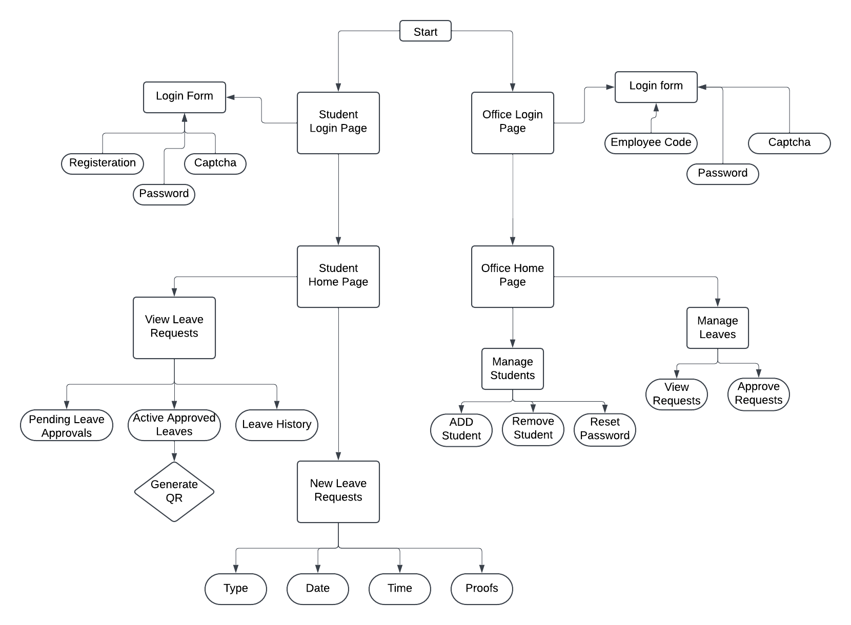

**Team members:**

| **S.No** | **Reg.no** | **Name** |
| --- | --- | --- |
| 1 | 23BCE1861 | Ramanuj Agarwal |
| 2 | 23BCE1498 | Navneet Singh |
| 3 | 23BCE1691 | Pokharkar Om Nitin |

**References:**

1. Dean J., Web Programming with HTML5, CSS and Javascript. Jones and Bartlett Learning 2018
2. Minnick C., Beginning ReactJS foundations building user interfaces with ReactJS: An approachable guide, OReilly, 2022.\
3. <https://www.researchgate.net/publication/356564842_Importance_of_login_form>
4. <https://dl.acm.org/doi/abs/10.1145/1459352.1459357>
5. Angelova, R. and Siersdorfer, S. 2006. A neighborhood-based approach for clustering of linked document collections. In Proceedings of the 15th ACM International Conference on Information and Knowledge Management (CIKM). ACM Press, New York, NY, 778--779.
6. <https://www.oracle.com/index.html>
7. https://www.w3schools.com/html/default.asp

Laura Lemay, Rafe Colbum and Jennifer Kymin, Mastering HTML, CSS and Javascript Web Publishing, BPB Publication, 1st Edition, 2016.